**Black Friday**

**Data Acquisition :**

1. As black friday is very popular and available on the internet for free, downloaded from Kaggle.
2. Imported the data from train.csv file and displayed in a table.

**Data Cleaning :**

As always imported data is always having some missing values, checked for the same.

Found missing values on the column “**Product_Category_2**” & “**Product_Category_3**”

As observed both column is filled with categorical value, hence filled the missing value with their ID which is having the max value.

**Exploratory Data Analysis :**

**Univariate Analysis :**

Total Number of Unique Customer : 5891

Total Number of Unique Products : 3631

Total number of unique Product belongs to Product_Category_1 is : 20

Total number of unique Product belongs to Product_Category_2 is : 17

Total number of unique Product belongs to Product_Category_3 is : 15

While grouping the data by Occupation, I found that males are in high count they used to purchase more on that day rather than any female irrespective of which group they belong to.

**Bivariate Analysis :**

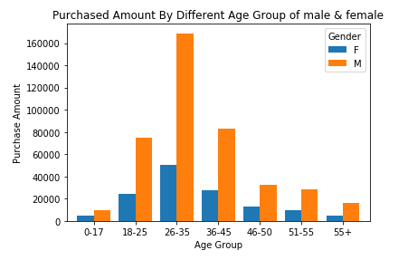

By looking & observing the Black Friday data, it is very much clear that except the last column **“Purchase”,** all the columns are filled with categorical data.

Tried to visualize the data by grouping Age to understand the purchasing pattern of individual age group while taking into consideration the Gender.

By looking to the plot, it is clear that people belong to age group 26-35 are usually purchase more than any other group. We can also conclude that males are more prone to purchase items on that day rather than female.

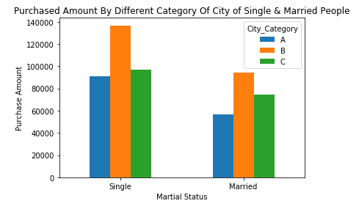

People belongs to different City along with their marital status also differs on that day.

By looking at the plot, it is clear that people belong to City of Category B is more likely to purchase items on that day and most of them are single.

We can conclude that irrespective of city category people who are single is more prone to purchase while married couples are conservative in nature.

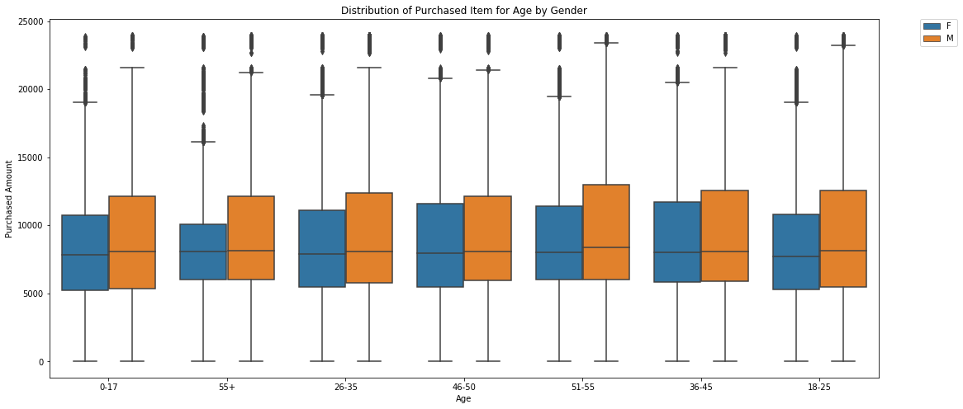

It's clear that irrespective of age, males are more prone to purchased item.

In Spite of Age, we could see outliers for all the Purchased Amount of distribution for females is found which indicates girls belong to rich families are more attracted to shopping.

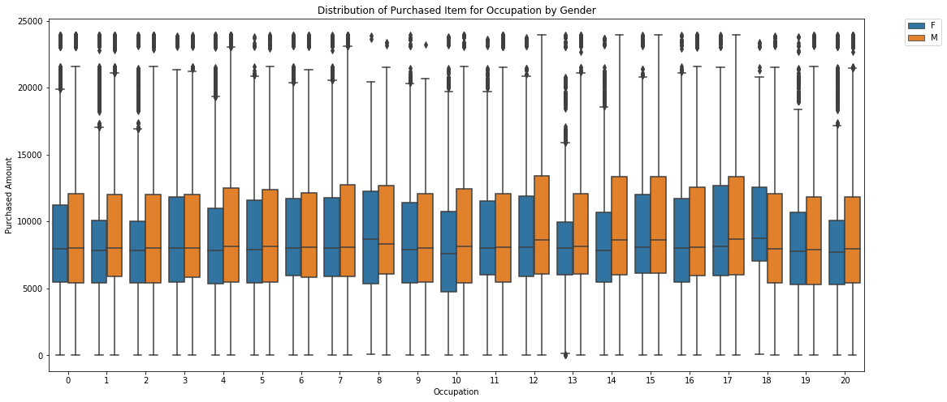

People belong to occupation type - 12, 14, 15 & 17 's purchasing is more than others especially for males. Females are conservative in nature and only the outliers that indicates few belongs to rich status are shopping more than anyone.

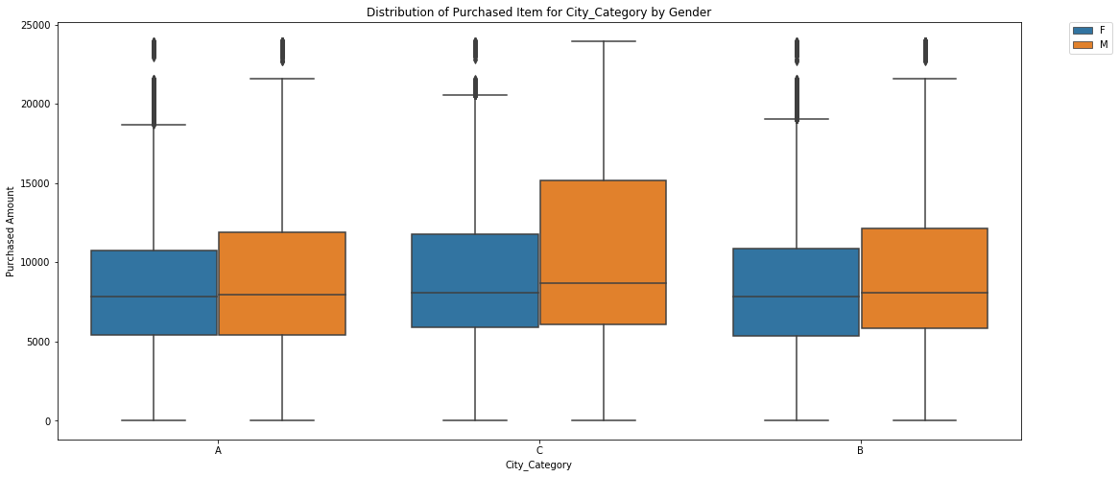

People belongs to city C are more comfortable with shopping which can be concluded that City C is more highly status people live

Males are always more prone to purchase

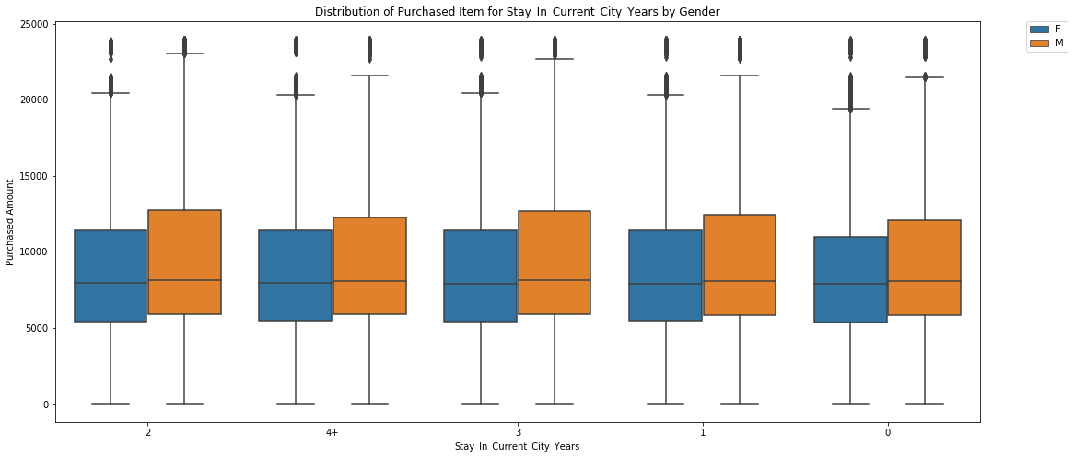

People's living time doesn't vary the Purchasing Items among them and it lies the same for male & female throughout the cities. Males are highly interested than female to purchase

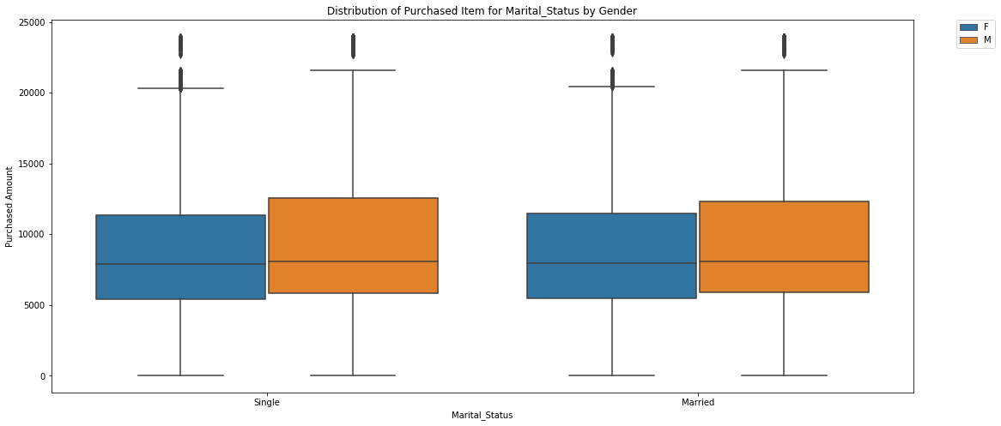

Married People are more conservative in nature while shopping. Single males purchased more than female. But few females belong to rich status family are more prone to shopping than any other.

**By looking at various countplot, I reached a conclusion:**

1. Only Product 1, 5 & 8 belongs to Product_Category_1 were being brought by people irrespective of any group Gender, Age, Occupation, City_Category, Stay_In_Current_City_Years, Marital_Status
2. Only Product 8 belongs to Product_Category_2 were being brought by people irrespective of any group Gender, Age, Occupation, City_Category, Stay_In_Current_City_Years, Marital_Status
3. Only Product 16 belongs to Product_Category_3 were being brought by people irrespective of any group Gender, Age, Occupation, City_Category, Stay_In_Current_City_Years, Marital_Status
4. Males are very much prone to Purchasing Item than females irrespective of any group Gender, Age, Occupation, City_Category, Stay_In_Current_City_Years, Marital_Status

**Multivariate Analysis:**

There is no linear relationship among Gender, Age, Occupation, City_Category, Stay_In_Current_City_Years, Marital_Status with respect to Purchase & each other.